

User Guide

Major Programming Assignment Stage 3

Jack Carey, IS1201

Table of Contents

Hardware Specifications 3

Minimum 3

Recommended 3

Installation Guide 4

Extracting 4

Opening the game 5

Gameplay 6

Starting the game 7

Interface 8

Controls 9

Power Capsules 9

Power Ups 10

Speed Up 10

Laser 10

Rapid Fire (?) 10

Scoring 11

Ending the game 11

Troubleshooting 12

# Hardware Specifications

## Minimum

**Architecture:** 32-bit or 64-bit CPU  
**Operating System:** Windows 7 or later  
**Processor:** 1.6 GHz or faster  
**Memory:** 2 GB RAM  
**Graphics:** DirectX 9 or later capable graphics card  
**Network:** Not requiredfor operation  
**Storage:** 20MB available space

## Recommended

**Architecture:** 64-bit CPU  
**Operating System:** Windows 10  
**Processor:** Intel Core i5-4460  
**Memory:** 8 GB RAM  
**Graphics:** nVidia GeForce GTX 960 2GB  
**Network:** Not requiredfor operation  
**Storage:** 20MB available space

# Installation Guide

## Extracting

Once you have downloaded the project file from the internet, you have to extract the .zip file to a convenient location to save and run the game.

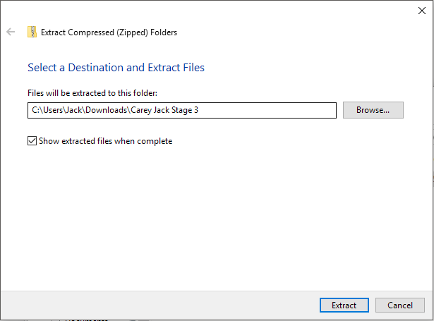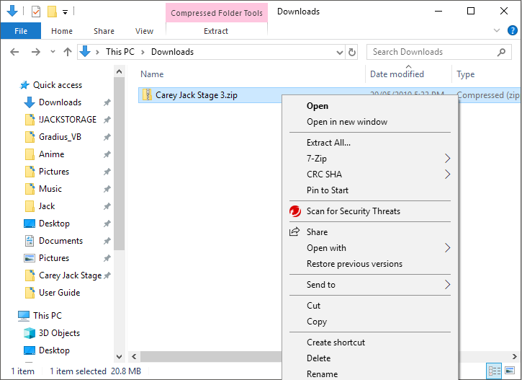Simply locate the .zip file (usually located in your Downloads folder), right click on it, select “Extract all”, and follow the prompt to extract the file.

## Opening the game

Find the newly extracted folder, open the folder, open the “GradiusVB – Game” folder, and double click on “GradiusVB.exe”. This will start the game!

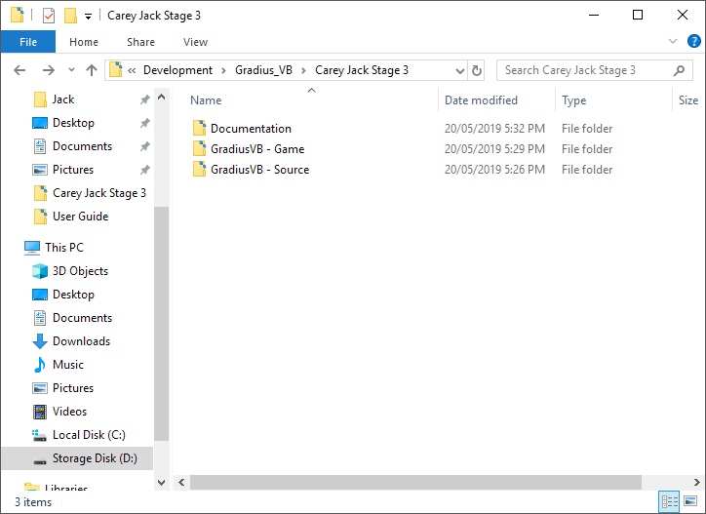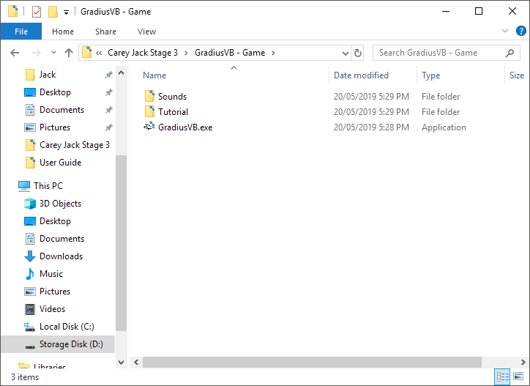If you wish to browse the source code of the game, access the “GradiusVB – Source” folder. If you wish to read this user guide or see the structure chart of the program, access the “Documentation” folder.

# Gameplay

Gradius is a side-scrolling space shooter, originally released as a coin operated arcade game in Japan in 1985 by Konami. This version is a recreation of the home release version on the Nintendo Entertainment System (NES). In fact, this game was the first to include the well known Konami code as a secret cheat code!

The object of the game is to defend against an oncoming hoard of alien spacecraft by avoiding enemy fire and destroying as many enemies as you can! The Vic Viper, your space fighter, starts with only three lives. Survive as long as you can and try and get the high score! The developer’s high score is 52,800! Over time the game becomes more and more difficult as enemies gradually speed up. Can you endure their pressure?

Use the power-ups you find when destroying enemies to upgrade the Vic Viper’s engines and weapons systems to increase your chances of survival!

## Starting the game

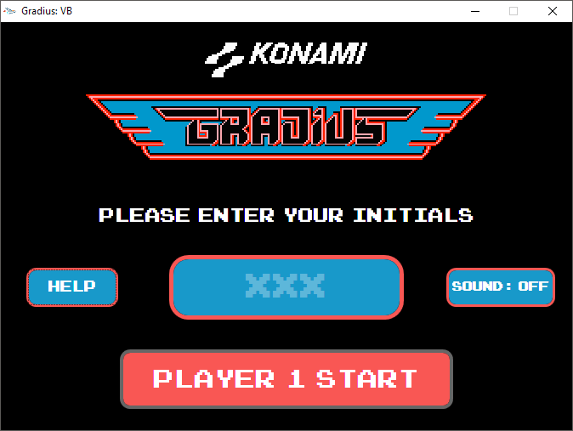When you open the game, you will be greeted with the following screen.

|  |  |
| --- | --- |
|  | Click this button to view a help screen and view an interactive tutorial. We recommend viewing this before playing for the first time. |
|  |  |
|  | Click this button to toggle sound effects. We recommend toggling sound on for an authentic retro experience. |

To begin, enter your initials, ensuring they are three capital letters, and click “Player 1 Start” or press Enter.

## Interface

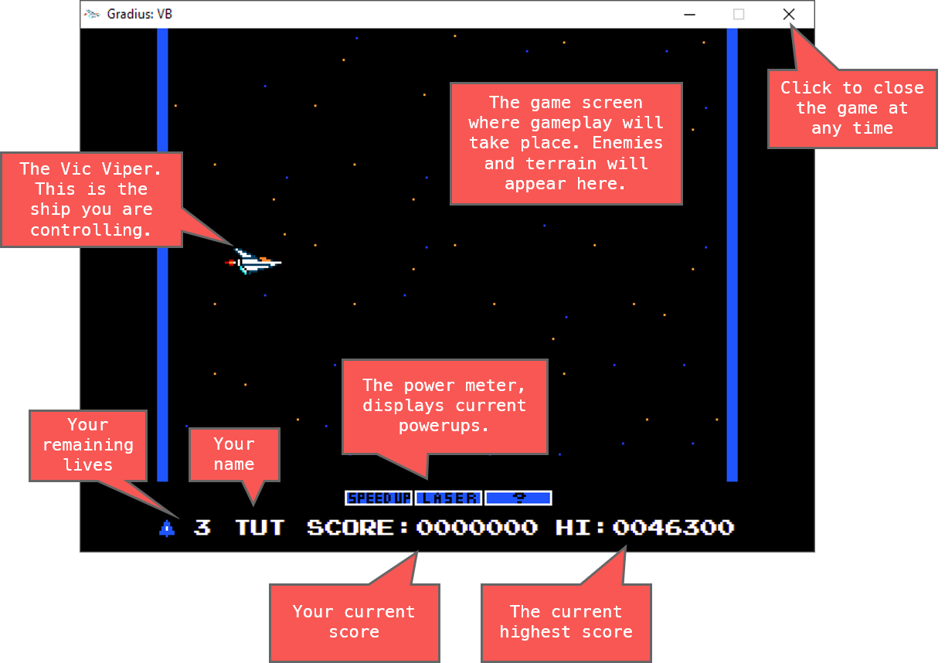Below is a description of the screen gameplay screen and it’s interface elements.

## Controls

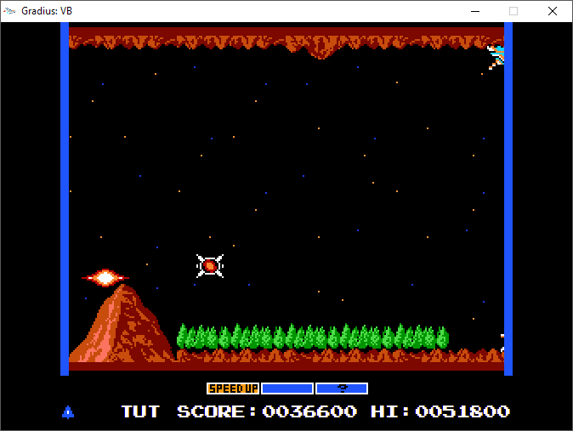Use the arrow keys on your keyboard to move the Vic Viper up, down, left, right, and diagonally by using a combination of keys. Be careful! The Vic Viper is fragile and will be destroyed immediately when it crashes into terrain, enemies, or enemy bullets. Keep your wits about you, pilot!

Crash! Just missed a power up...

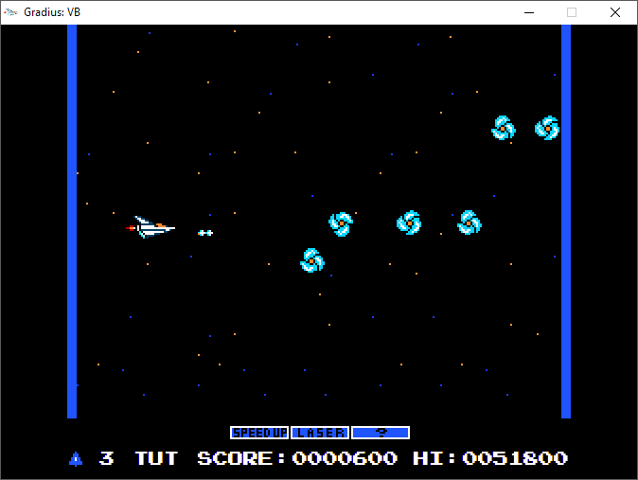

The Vic Viper has a sophisticated on-board armanent system which can be fired using the “A” key. Press it to fire a single bullet.

Use the “S” key to activate the power ups you collect as you destroy enemies on your journey.

## Power Capsules

When you destroy red enemies or an entire formation of enemies, a Power Capsule will be dropped. Collecting the capsule increments the power meter at the bottom of your screen by one. When the power up you want to purchase is highlighted, simply press the “S” key to activate it! Simply collecting a Power Capsule does NOT activate a power up.

## Power Ups

### Speed Up

The first power up in your power meter is Speed Up. Activate this for a boost in the Vic Viper’s engine capacity and movement speed! But be careful – you can activate this power up as many times as you like, and eventually the Vic Viper may become uncontrollable!

### Laser

This power up upgrades your weapons from a kinetic based weapon to a laser weapon. Your shots will now pierce enemies and can destroy many alien spacecraft in one shot! Note only one of Laser or Rapid Fire can be active at one time.

### Rapid Fire (?)

A power up which many players may not at first understand without reading the manual! Normally, the Vic Viper can only fire two bullets at a time. This power up overclocks the Vic Viper’s weapons systems to enable it to fire at a blistering rate. Press the fire key as much as you want to fire bullets at a dramatically increased speed!

## Scoring

There are 4 different types of enemies in the game. It is up to you to learn their behaviours and movement patterns to effectively out manoeuvre and destroy them!

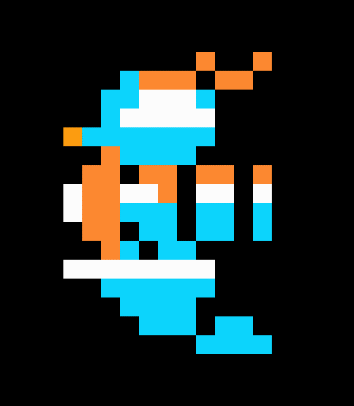Each enemy you destroy will net you 100 points, and each Power Capsule you collect will net you 500 points! Aim to collect as many as you can to earn big scores.

## Ending the game

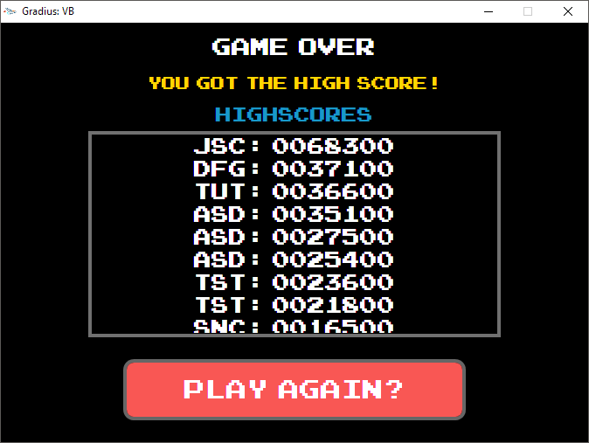Once you lose all your lives and a destroyed for the final time, you will be presented with the game over screen. You will see you initials in the list of high scores. Try to make it to the top! If you do, you will be notified with a line of golden text:

At this point, you can either close the game with the “X” at the top right of the screen, or you can play again by pressing “Play Again?” at the bottom of the screen. Note that if you close the game before reaching the game over screen, your high score won’t be recorded!

# Troubleshooting

|  |  |
| --- | --- |
| **Problem(s)** | **Resolution** |
| * **I can’t start the game!** * **The interactive tutorial won’t load!** | Ensure that the executable file is extracted from the zip folder before running the game. |
| **Sound effects aren’t working!** | Ensure that you have toggled the sound setting to “ON” when you first open the game. |
| **The game is laggy and has glitches!** | Ensure you computer meets the minimum hardware requirements before playing. |
| **The game crashed and I lost my high score!** | Unfortunately, your high score is not able to be recovered, however if you report the crash details to the developer the problem can be resolved in a future patch. Restart the game by double clicking your executable again. |
| **The game is too hard! I keep dying!** | Continue to practice, and get good. ***TIP****: The Laser is a very strong power up you should try to unlock straight away.* |